As Reconstruction progressed, South Carolina’s cities were rebuilt. In this lesson, you will look at several “bird’s-eye” views of Columbia and Charleston and examine them for evidence of growth.

Instructions: Use the information at the links to complete each item below.

Library of Congress American Memory
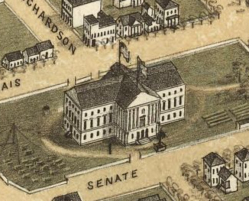
- Click the link above.
- Type “Charleston” in the site’s search bar to search “This Collection,” and click the magnifying glass to search.
- Click on the picture of the map.
- Click the button to download a copy of the map to your device. Try several of the options to see which works best for you. It may be best to download the image to your device, and then open it in an image viewer.
Bird’s Eye View of Columbia, SC - 1872
Source: Library of Congress, Geography and Map Division

- How many years had passed since the Civil War had ended and the creation of this map? __________________

- Identify at least three types of transportation on the map.
__________________________________________________________________
__________________________________________________________________
- Identify one of the railroads that served the city (see key at bottom)? __________________________________________________________________

- What important building is identified with an “15” on the map? __________________

- What types of buildings can you locate (list four)? __________________________________________________________________

- Describe the area around the city.
__________________________________________________________________

- In the search bar for This Collection, type “Columbia” and click the magnifying glass to search.
- Click on the picture of the map for Columbia, South Carolina.
- Download the image as before.

- At the time this map was published, how many years had passed since General Sherman’s troops burned the city? __________________

- Identify at least three types of transportation you can locate on the map. __________________________________________________________________

- Describe at least three differences that you notice from the previous map. __________________________________________________________________

__________________________________________________________________

Click the links below. Take a few minutes to study the maps and how to navigate using them. Try to orient the map in a way similar to one of the maps from the Library of Congress that you just viewed. Complete the Venn diagram to compare the 19th and 21st century views of the cities.
21st Century View of Charleston 21st Century View of Columbia

21st Century Map
19th Century Map

